LIVE from SuperBizCamp! – part 1

http://www.supercamp.com/summerstudy/2013/08/superbizcamp-journa/
Leave a reply
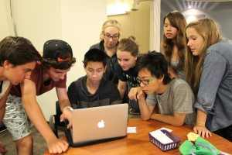

I don’t know if it was my dashing good looks or my rave review of SuperCamp Junior Forum last week, but I got the chance to come back for the second half of SuperBizCamp and OH-MY-GOSH, IT IS AWESOME! Really, talk about a great day at work! Yes, I work for SuperCamp so you might think I am biased, but I’m hoping the caps and exclamation points portray my sincere appraisal of this new SuperBizCamp program!!!!!
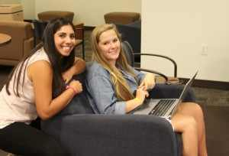

I arrived at this morning and the students were hard at work in their business partnerships. I took the opportunity to snap some photos and ask some questions and came away impressed. These teenagers (ranging from 14- to 19-years-old) are getting great business principles and practical application and are absorbing it all like CEO’s in the making.

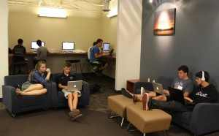
They are engrossed in their projects and always eager to know when they’ll have more time to work on them, including skipping their cell phone time – a SuperCamp first, I’m sure!
Their business ideas are also interesting and inspiring, several of which are charity-based. I am impressed with their sharp minds and willing spirits. They have great attitudes, which I didn’t entirely anticipate. They are working hard and excited about starting their own businesses and helping others.
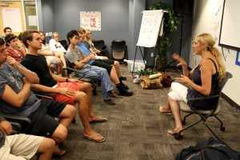

We were fortunate to have Nancy Gale, founder of handbag company, Jamah, and her non-profit, In True Fashion, as our guest speaker today. She taught us the importance of socially conscience business and being inspired by your business by dedicating it to a cause you are passionate about. It was great advice and made an impact on everyone there, including the adult leaders.
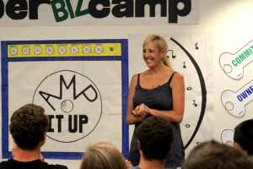

She gave out her business cards with a warm smile and willingness to help these students in the future however she can. Part of the focus of SuperBizCamp is teaching students to build their professional network so these guest speakers are an excellent start and provide wonderful opportunities they wouldn’t otherwise receive.
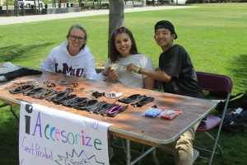
Following our guest speaker session, we grabbed a quick lunch, as entrepreneurs often do, and then jumped into the selling arena. We had a selling event where students hosted booths to sell their wares. These wares included a variety of merchandise which they bought yesterday In the LA Fashion district. Their products ranged from inexpensive keychains and bracelets to mobile speakers and t-shirts.

We received great moral support from passersby, if not financial. Several offered words of wisdom but one, in particular, went above and beyond, offering an on-the-spot sales class. He gave the team a run-down on what their pitch should be, how to establish rapport and find a sales pitch angle, then had them practice their pitches several times more. He was a great inspiration and the students were grateful to benefit from his expertise and willingness to impart a small share of it on his way to the library. He received many thanks and a cool bracelet for his troubles.
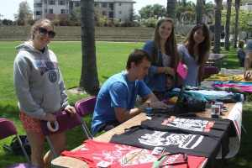It was interesting to see the students in action. Some were very outgoing from the start, while others preferred a less aggressive sales approach. It was nice to be able to coach students in the moment, during their sales pitches, so they could see how slightly different wording might make or break their sales. I appreciated that these students were so open to feedback and wanting to learn more. This was great practice and I only wish they could do more of it to further hone their skills. Hopefully they will do exactly that when they return home with their business plans in hand.
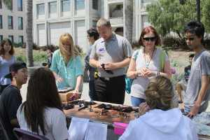

Debriefing on the selling event was also enlightening. The students identified their strengths and weaknesses and determined action steps. They also realized the variables involved with any business venture, which I think was one of the most valuable lessons.
The rest of the evening was spent working on projects, building and rehearsing tomorrow’s business plans presentations. These kids are enjoying the competition and taking it very seriously which is great to see in these budding young entrepreneurs. Looking forward to some amazing presentations tomorrow!

LIVE from SuperBizCamp – part 2

http://www.supercamp.com/summerstudy/2013/08/superbizcamp-journal-day2/
Leave a reply
Today was awesome. These young entrepreneurs were so focused on fine-tuning their presentations, practicing over and over, and writing out notecards like their lives depended on it. We worked and practiced all morning and the anticipation for the SuperBizCamp Business Plan Competition was palpable.
Before lunch, each team presented to each other and voted on which of the partnerships would represent the group in the competition. It was difficult with so many excellent business ideas and everyone having worked so hard, but each team finally did. This was a good opportunity in and of itself to get a glimpse of some of the tough choices required in business.
I was so impressed by the variety and creativity of each of these partnerships business and charitable causes they selected:
- B.E.A.R.S. (Bears Encouraging Awareness Regarding Safety), a buy one-get one teddy bear program, presented by Sterling and Courtney, to provide teddy bears to abused children.
- Cascara, scented sunscreen, presented by Peyton and Uto, to benefit skin cancer research.
- Clique In, a new social media site to find social events in your area, presented by Gary and Simon, benefitting ASPCA to end animal abuse.
- Dot 2 Dot, a job matching website, presented by Izzy and James, to help Seattle Foundation to aid local employment efforts.
- Grenna Blics decorative blind decals, presented by Chris and Samantha, to help provide cataract surgeries in third world countries.
- ITS (In The Spotlight), an artist promotion site, presented by Ethan and Nolen, to benefit Art & Fashion and SavingMusic, which helps underprivileged schools arts programs.
- L.I.C. (Leadership Integrity Courage), a T-Shirt company to support Veterans and show pride and gratitude for their service, presented by Blake, to benefit Veterans.
- Maji Safi water bottles, presented by Tracy and Steven, to provide clean water in Africa.
- Part II, designer fundraising bracelets, presented by Alyssa and Drew, to help give the homeless a second chance at success.
- PineappleBanana, a script analysis website for aspiring writers, presented by Uri and Tommy, and benefitting Teach For America for educational equity.
- Salvaged Wallet, wallets made of recycled materials, presented by Darian and Johnny, to help provide sanitation in third world countries.
- Tea Day, presented by Madeleine, to help provide clean water in Africa.
We had round one of our SuperBizCamp Business Plan Competition this afternoon, where each partnership presented before their team and our three judges. Following their 8-minute presentation, each business partnership fielded questions and received feedback to further refine their presentations and continue to teach the finer points. Every judge agreed that every single business that these partnerships presented could easily succeed if they pursued them.
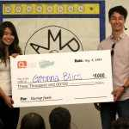Following dinner, we returned to our main room and the five semi-finalists were announced. It came down to Cascara, Clique In, Dot 2 Dot, Grenna Blics and Part II. Each team did an exceptional job presenting and their scores were all within a couple points of each other but Grenna Blics won out, taking home the $3,000 seed-money prize.
That evening was our last at SuperBizCamp. It was bittersweet indeed and many tears were shed, as students reflected on the week, their new friendships, their futures together and their impending separation to return home. I still cannot believe the powerful connections this group of teenagers made in just one week. The teens determined to have a reunion in one year and to encourage each other to pursue in their businesses in the meantime.
Graduation was awesome, of course, and more tears were shed by students and parents alike. I expect to see each of these teen entrepreneurs on the cover of Forbes someday. I am looking forward to next year when I can see what they’ve accomplished and hope to get updates in the meantime. Until then, keep your eyes open for these products and help support these young entrepreneurs!

