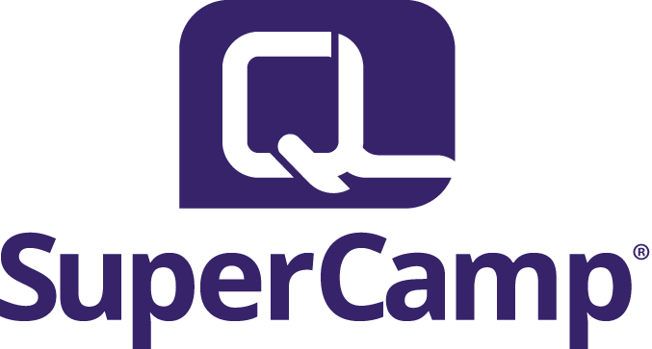

Marketing Plan
2014

2014 Marketing Plan
SuperCamp

Effective Dates: September 1, 2013 – July 1, 2014

Situation Analysis:

SWOT Analysis
Strengths | Weaknesses
- Time is on our side to start marketing now  - Product is excellent; well-rounded, well-established, good reputation.  - Marketing Team is talented, devoted to success | - Limited man-power in marketing—big job  - Previous department turnover-its effects on internal and external relationships/morale  - Product is expensive  - Nurturing Grads for re-enrollments
Opportunities | Threats
- New Tools – HootSuite, Meltwater  - Can bundle products to promote: LeFo to SC to SuperBizCamp, add webinars, home study, etc. | - Competitors—so many options  - Free online resources  - Tight economy

Audiences:
2013 SuperCamp Graduates (1,227 email addresses)
2013 Grad Parents (1,789 unique email addresses)
2011-2012 Graduates
2011-2012 Grad Parents
2011-2013 Open Leads
TOTAL Primary Audience

Secondary Audience:
Grandparents (general population, ages 55-75)
Select Parents (parents, especially mothers, with household income of $200,000+)

Tertiary Audience:
Educators
Media

Product Overview:
SuperCamp is a residential academic summer camp designed to teach academic, character-building and social skills in a safe and engaging environment. At their foundation, Junior Forum, Senior Forum and Quantum U are designed around the same core ideology, but with age-appropriate examples and context. Leadership Forum and SuperBizCamp add special emphasis on learning skills specific to leadership and business, respectively.

Junior Forum:
Junior Forum is a 7-day program uniquely designed for students entering grades 6 – 8. Special emphasis is given to teaching time management, organization and social skills to lay a strong foundation for academic and personal success.

Senior Forum:
Senior Forum is a 10-day program for students entering grades 9 – 12. Senior Forum is specifically designed to help high school students build upon their academic foundation with special focus on study skills, communication techniques and fostering positive relationships, to achieve high school success and career and college readiness.

Quantum U:
Quantum U is an 8-day program for incoming and existing college students. It is primarily designed to help college students excel in collaboration, critical thinking, communication and creativity. Quantum U helps students obtain the best education possible, while learning how to navigate their new-found independence to get the most out of their college education and experience and successfully transition into careers and adulthood.

Leadership Forum:
Leadership Forum is for students who wish to learn additional leadership skills, beyond those taught at Senior Forum. During Leadership Forum, students take the 8 Keys of Excellence to the next level with the Four Diamonds of Leadership: Vision, Model, Team and Action. We create an atmosphere where students set goals in an experiential setting and gain confidence in public speaking and personal expression, culminating in students creating a leadership initiative in their own community. By the end of the program students understand what their strengths are as a leader, the role they play on a team, and how to bring out the best in others.

SuperBizCamp:
SuperBizCamp is an intensive 8-day business course for young entrepreneurs. SuperBizCamp teaches teens how to be successful business owners with special emphasis on social responsibility and ethical entrepreneurship. During these 8 days, students create their own product and write and present their business plan to win seed money to launch their business.

SuperCamp Features: | SuperCamp Benefits:
30+ years in business | - Trustworthy, experienced  - Everything is ‘on purpose’ with a scientific brain training strategy behind it  - Safe place for students  - Full background checks for all staff  - Controlled, safe environment  - Very Low student-leader ratio
Exceptional staff | - Most are full-time teachers during the school year = experienced and well-educated, love students and teaching  - Excited to be there; attend ‘try outs’ and many hours of additional training to be SuperCamp ready each year
Holistic approach | - Brain and body, whole person experience to improve academics and social skills  - Increase Grades, Confidence AND Motivation
Held on prestigious college campuses throughout the US | - Students have the opportunity to exercise their independence in a controlled environment  - Nice keywords for applications  - Students get a feel for college life and perhaps more motivation to get there  - Parents don’t have to drive to summer activities
Pattern interrupt | - Gets students out of their normal routines to instill new information and more productive habits  - Opens them up to socialize and accept new ideas
Scientifically-based, proven academic strategies | - Students learn how the brain works, so they can work smarter, not harder  - Learn practical strategies that are fun and easy to learn/replicate at home  - Opportunities to practice/reinforce new strategies to implement easily at home  - Test scores, academic confidence, grades increase  - New strategies  - Natural learning
Character-building and Team-oriented | - Increase responsibility, respect for self and others, trust, confidence  - Gain communication, leadership, problem-resolution, teamwork and social skills  - Decrease behavioral issues

Messaging:
SuperCamp is all about empowering students to reach their potential. Its power comes from the heart, passion, pride and sense of accomplishment that our students gain as they experience the SuperCamp transformation.

This power is what helps keep students motivated all year long and excited to return each summer. Parents’ desire to help their students increase their grades, confidence and motivation comes from a place of love so we need to speak to that in all that we do.

Also, like anything we love, parents and students are anxious to share this joy with others. We want to capitalize on this first-hand passion by encouraging them to ‘share the love’ to increase grad referrals.

Overarching Theme for 2014:

I SuperCamp >>> All Heart, and Smart too! >>> Share the love!

Tagline: “Increase Grades, Confidence and Motivation.”

***Wherever possible, each product should be marketed individually to specific audience (specific to ages of children and their particular benefits)

Plan Objective:
To successfully promote the SuperCamp brand and its core products (Junior Forum, Senior Forum, Leadership Forum, Quantum U, SuperBizCamp) in order to achieve 2,490 total enrollments and increase overall brand awareness for future enrollments.

Goals:
The following goals are designed to quantify our progress achieving the objective:
- 2,490 total SuperCamp Enrollments from 25,000 qualified Info Requests
  - 868 Junior Forum Enrollments (8 sessions)
  - 1,382 Senior Forum Enrollments (12 sessions)
  - 80 Quantum U Enrollments (1 session)
  - 80 Leadership Forum Enrollments (1 session)
  - 80 SuperBizCamp Enrollments (1 session)
- Monetize Social Media Efforts
- Increase SuperCamp brand awareness

Strategies & Tactics:

Goal 1: 2,490 total SuperCamp Enrollments from 25,000 qualified Info Requests

Strategy 1: Online Advertising
Gain attention and new leads for Sales Department to convert, entice direct sales.

Tactics:
Summer Camp Directories
MySummerCamps.com ($15,915)
KidsCamp.com ($5,642)
CampPage.com ($1,074)
SummerCamps.com ($4,000)
CampNavigator ($0)

Measures:
Summer Camp Directories:
Goals: 1,200 total Info Requests / 80 Enrollments
MySummerCamps.com: 600 / 40
KidsCamp.com: 150 / 10
CampPage.com: 300 / 20
SummerCamps.com: 150 / 10

NOTE: Need monthly breakdown tracking for these sources

Benchmarks: Compare Actuals to Goals on the 15th and 30th of each month and adjust accordingly where possible.

PPC Advertising
Google/Bing (Denver PPC) – Match spend ($200,000) and distribution from 2013. Improve ad copy and images to achieve more qualified leads (Info Requests) and increase conversion rates.

Facebook (Internal) – Reallocate $40,000 of the Direct Mail Budget to Facebook ads for targeted demographics for most qualified leads.

LinkedIn (Internal) – Reallocate $19,000 of the Direct Mail Budget to LinkedIn ads for targeted demographics for most qualified leads.

Measures:
PPC Advertising
Google/Bing:
Increase conversion rate from 10% to 11.25%
(11.25% of monthly spend)
Increase from 20,000 to 25,000 Qualified Info Requests

Benchmarks: Compare Actuals to Goals on the 15th and 30th of each month and adjust accordingly.

Facebook:
Achieve 10% conversion rate per month (of monthly spend)
Get 4,000 highly qualified Info Requests

Benchmarks: Compare Actuals to Goals on the 15th and 30th of each month and adjust accordingly.

LinkedIn:
Achieve 10% conversion rate (of monthly spend)
Get 1,900 highly qualified Info Requests

Benchmarks: Compare Actuals to Goals on the 15th and 30th of each month and adjust accordingly.

NOTE: If any of these media outlets performs better, budgets allotted to individuals may be re-distributed to capitalize on performance.

Spend Distribution and Anticipated Results (in the form of Info Requests):
 | Jan | Feb | March | April | May | June | July | Approximate  Totals
 | 2.9% | 7.18% | 18.46% | 20.47% | 22.66% | 19.04% | 9.21%
Denver PPC | $5,970 | $14,516 | $37,309 | $41,367 | $45,806 | $38,476 | $18,617 | $202,060 spent
x 11.25% conversion rate | 671 | 1,633 | 4,197 | 4,653 | 5,153 | 4,328 | 2,094 | 22,729  Info Requests
Facebook | $1,160 | $2,872 | $7,384 | $8,188 | $9,064 | $7,616 | $3,684 | $40,000 spent
x 10% conversion rate | 116 | 287 | 738 | 818 | 906 | 761 | 368 | 3,994  Info Requests
LinkedIn | $551 | $1,364 | $3,507 | $3,507 | $4,305 | $3,617 | $1,749 | $19,000 spent
x 10% conversion rate | 55 | 136 | 350 | 350 | 430 | 361 | 174 | 1,856  Info Requests
Total Spend | 7681 | 18752 | 48200 | 53062 | 59175 | 49709 | 24050 | $261,060
Info Requests | 842 | 2,056 | 5,285 | 5,821 | 6,489 | 5,450 | 2,636 | 28,579
[Values are approximate/have been rounded to nearest dollar]

Strategy 2: Public Relations
Increase search engine rankings, increase social community engagement, provide information, gain a wider audience, and entice sales.

Tactics:
SuperCamp Blog (weekly)
Guest posts on External Blogs (weekly)
Huffington Post Articles (weekly)
Press Releases (monthly)
Social Media Posts (daily)
Camp Directory Articles
Develop a targeted lists of applicable media sources

Measures: Increase traffic to SuperCamp.com; decrease in Bounce Rate

Strategy 3: Direct Contact
Nurture relationships with Return Grads, Return Grad Parents and Open Leads for additional sales, entice new sales.

Tactics:
eBlasts (weekly)
Voicemail blasts (as needed)
Program-specific newsletters (monthly)
Grad support videos (monthly)
Summer Camp Fairs (as scheduled)

Measures:
eBlasts: 25% Open Rate and 2% Click Rate for Grad Parents
10% Open Rate and 1% Click Rate for Open Leads

Strategy 4: Revise SuperCamp.com
Increase ease of use (navigation), increase conversions, decrease bounce rates, streamline enrollments, increase engagement and build rapport, provide a gathering place/resources for grads, parents, general public with teen support, parenting and education information.

Tactics:
Streamline design of site
Responsive design for mobile devices
Capitalize on RSS subscriptions

Measures:
Decrease bounce rate from 72.14% to 50%
Increase traffic to site throughout the year (versus steep rises and falls)

[Overview of SuperCamp.com traffic for July 1, 2012 through July 31, 2013]

Goal 2: Monetize all social media efforts through HootSuite Enterprise, tracking codes and Google Analytics

Strategy 1: Receive 5 info requests and 1 enrollment from social media per month (off-season)

Tactics: Tracking codes on all social channels and cooperation with customer service and enrollments team to accurately track where leads and enrollments are coming from, e.g. “I heard about you online” prompts “Where online? Was it a social network such as facebook or twitter?”

Conversions From Social
June 59
July 58
August (to date) 3
September GOAL 5

June 2013
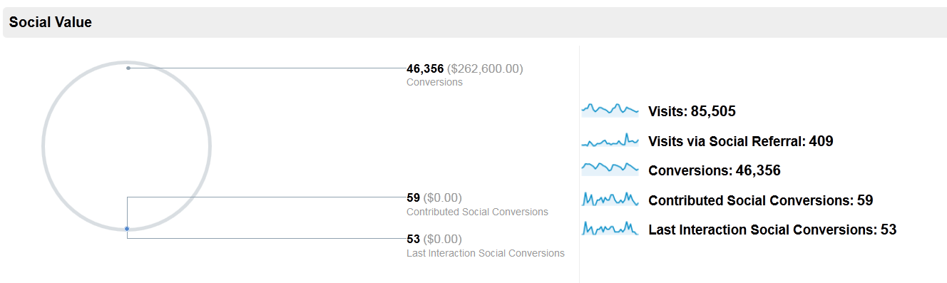

July 2013
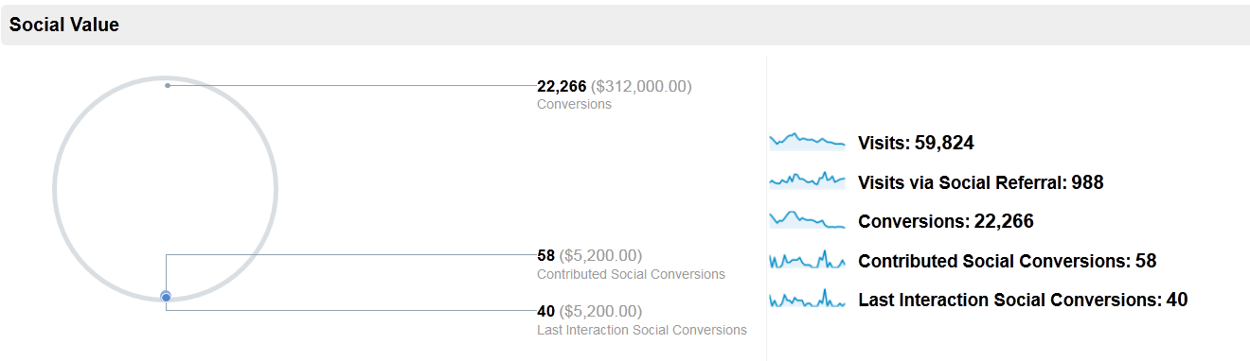
August 2013
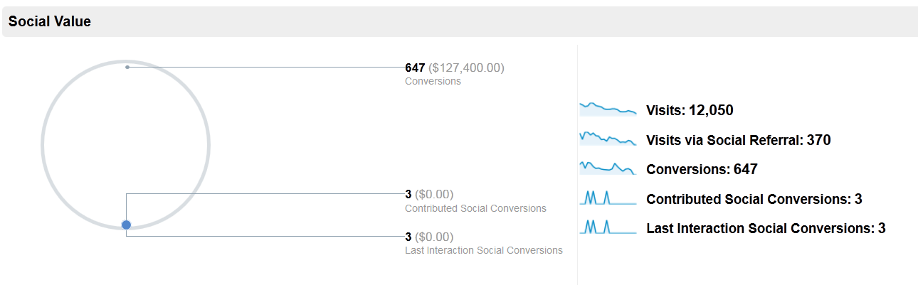

Strategy 2: Increased brand awareness, engagement and reach on social media

Tactics: Specific goals for social media communities (fans and followers) and engagement (RT, mention, reach, and TAT) measured through HootSuite Analytics

 | Social Media Community Measurement |  | Social Media Engagement |  | Facebook
 | New Facebook Fans | New Twitter Followers | RTs | Mentions | Weekly Total Reach  # people who have seen our page's content | Talking About This  # unique users who created a “story” about our page
June | 488 | 66 | 34 | 25 | 28,606 | 439
July | 408 | 254 | 71 | 89 | 7,151 | 367
August  (to date) | 93 | 120 | 59 | 66 | 5,566 | 260
September GOAL | 100 | 100 | 75 | 75 | 6,500 | 300

Strategy 3: Increased organic SEO from social media

Tactics: Google Analytics reports comparing traffic to site from social media (Supercamp.com)

June 2013: 409 Visits via Social
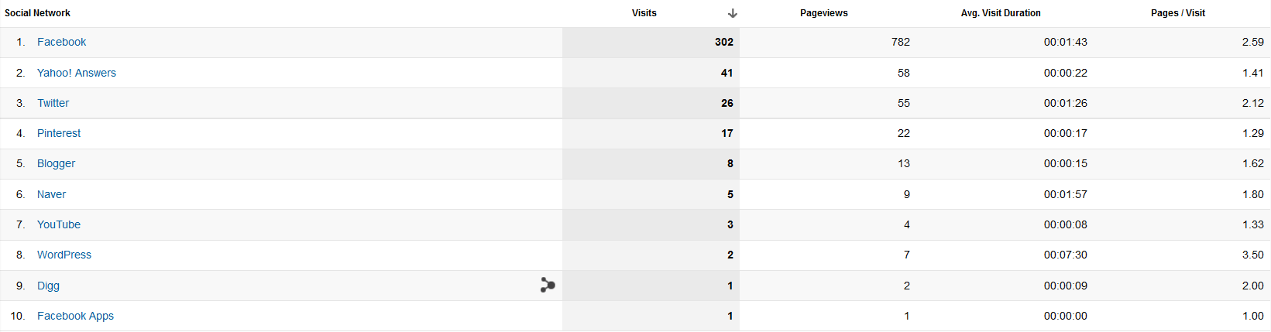

July 2013: 988 Visits via social
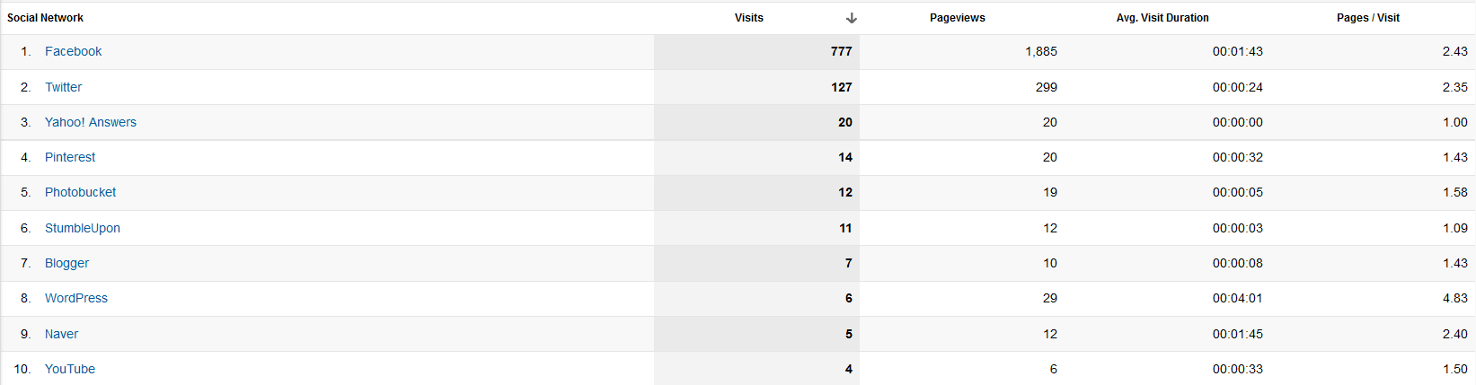

August 2013 (to date): 370 visits via social
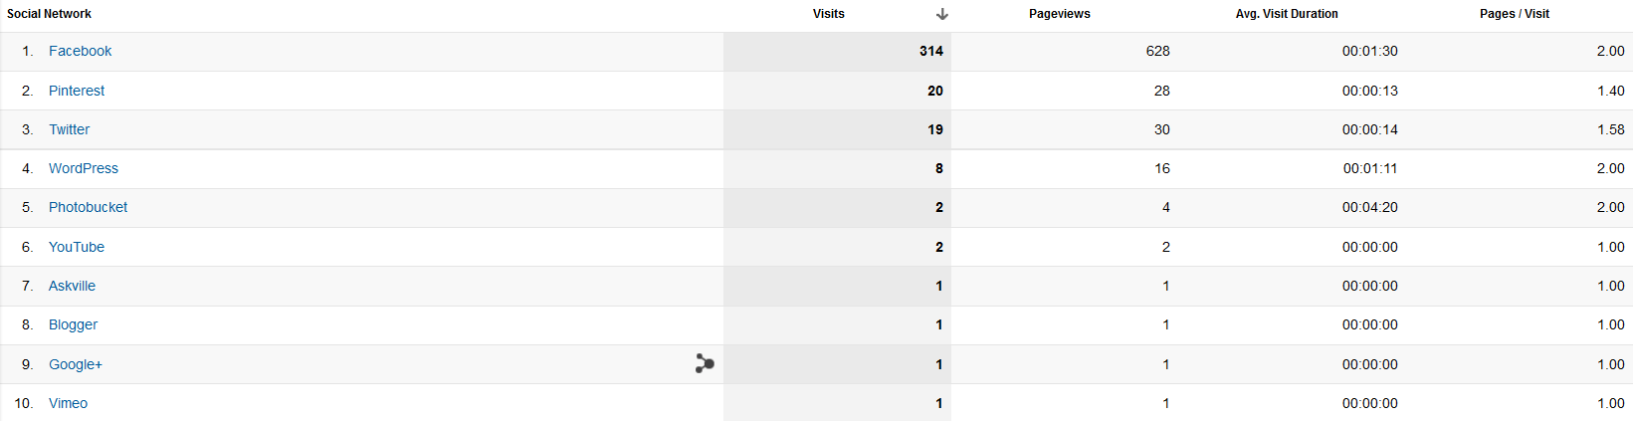

September 2013 GOAL: 400 visits via social

Goal 3: Increase SuperCamp brand awareness

Strategy 1: Social media
Increased organic SEO from social media; Increased brand awareness, engagement and reach on social media.

Tactics: Specific goals for social media communities (fans and followers) and engagement (RT, mention, reach, and TAT) measured through HootSuite Analytics

 | Social Media Community Measurement |  | Social Media Engagement |  | Facebook
 | New Facebook Fans | New Twitter Followers | RTs | Mentions | Weekly Total Reach  # people who have seen our page's content | Talking About This  # unique users who created a “story” about our page
June | 488 | 66 | 34 | 25 | 28,606 | 439
July | 408 | 254 | 71 | 89 | 7,151 | 367
August  (to date) | 93 | 120 | 59 | 66 | 5,566 | 260
September GOAL | 100 | 100 | 75 | 75 | 6,500 | 300

Strategy 2: SEO work
Optimize SuperCamp.com for search engines

Tactics:
External posts that link back to site
Maintain ‘fresh’ content on SuperCamp Blog (weekly)
Guest posts on External Blogs (weekly)
Social Media Posts link to site (daily)
Measure: Increase search engine rankings for keywords, increase number of links referring traffic to SuperCamp.com

Strategy 3: Public Relations
Increase search engine rankings, increase social community engagement, provide information, gain a wider audience, and entice sales.

Tactics:
Huffington Post Articles (weekly)
Press Releases (monthly)
Camp Directory Articles
Develop a targeted lists of applicable media sources

Measures: Increase traffic to SuperCamp.com; decrease in Bounce Rate

On-going Campaigns

Campaign: Price Break #1

Audiences:
2013 SuperCamp Graduates
2013 Grad Parents
2011-2012 Graduates
2011-2012 Grad Parents
2011-2013 Open Leads
Grandparents (general population, ages 55-75)
General Public (parents, especially mothers, with household income of $200,000+)
Educators
Media

Messaging:
Promote early enrollment by first discount date (October 1, 2013).
Get first choice of camps and the biggest discount. “This Is It” key.

Media Platforms:
eBlast, SM posts, SC website, SC blog, PPC ads, Facebook Ads, PR wires, newsletters

Tactics:
2 eBlasts per week (Tuesday and Thursday) tailored to targeted audience list
3 SM posts per week (Mon, Wed, Friday)
1 SC blog post
1 press release
Feature in Newsletter
Update website to Feature angle

Execution Dates:
September 2013

Campaign: Price Break #2

Audiences:
2013 SuperCamp Graduates
2013 Grad Parents
2011-2012 Graduates
2011-2012 Grad Parents
2011-2013 Open Leads
Grandparents (general population, ages 55-75)
General Public (parents, especially mothers, with household income of $200,000+)
Educators
Media

Messaging:
Promote early enrollment by second discount date (December 31, 2013).
Our holiday gift to them.

Media Platforms:
eBlast, SM posts, SC website, SC blog, PPC ads, Facebook Ads, PR wires, newsletters

Tactics:
2 eBlasts per week (Tuesday and Thursday) tailored to targeted audience list
3 SM posts per week (Mon, Wed, Friday)
1 SC blog post
1 press release
Feature in Newsletter
Update website to Feature angle

Execution Dates:
November - December 2013

Campaign: Price Break #3

Audiences:
2013 SuperCamp Graduates
2013 Grad Parents
2011-2012 Graduates
2011-2012 Grad Parents
2011-2013 Open Leads
Grandparents (general population, ages 55-75)
General Public (parents, especially mothers, with household income of $200,000+)
Educators
Media

Messaging:
Promote early enrollment by last discount date (April 15, 2014). Last chance!
Tax refund/break is here, who says nothing good happens on April 15?

Media Platforms:
eBlast, SM posts, SC website, SC blog, PPC ads, Facebook Ads, PR wires, newsletters

Tactics:
2 eBlasts per week (Tuesday and Thursday) tailored to targeted audience list
3 SM posts per week (Mon, Wed, Friday)
1 SC blog post
1 press release
Feature in Newsletter
Update website to Feature angle

Execution Dates:
April 1 - 15, 2014

Campaign: Geo-targeted (Location-based)
Audiences:
2013 SuperCamp Graduates
2013 Grad Parents
2011-2012 Graduates
2011-2012 Grad Parents
2011-2013 Open Leads
Grandparents (general population, ages 55-75)
General Public (parents, especially mothers, with household income of $200,000+)
Educators
Media

Messaging: Promote specific camps based on location.

Media Platforms:
eBlast, SM posts, SC website, SC blog, PPC ads, Facebook Ads, PR wires, newsletters

Tactics:
2 eBlasts per week (Tuesday and Thursday) tailored to targeted audience list
3 SM posts per week (Mon, Wed, Friday)
1 SC blog post
1 press release
Feature in Newsletter
Update website to Feature angle

Execution Dates:
On-going March – July, 2014

Campaign: Featured Program (promoting single program)

Audiences:
2013 SuperCamp Graduates
2013 Grad Parents
2011-2012 Graduates
2011-2012 Grad Parents
2011-2013 Open Leads
Grandparents (general population, ages 55-75)
General Public (parents, especially mothers, with household income of $200,000+)
Educators
Media

Messaging: Promote specific camps based on age of child(ren).

Media Platforms:
eBlast, SM posts, SC website, SC blog, PPC ads, Facebook Ads, PR wires, newsletters

Tactics:
2 eBlasts per week (Tuesday and Thursday) tailored to targeted audience list
3 SM posts per week (Mon, Wed, Friday)
1 SC blog post
1 press release
Feature in Newsletter
Update website to Feature angle

Execution Dates:
On-going March – July, 2014

Seasonal Campaigns:

Campaign: End of Summer Recap & Re-Enroll
Audiences:
2013 SuperCamp Graduates
2013 Grad Parents
Messaging to Grad Parents:
Get your first choice of camps now, keep the SC spirit going all year, save $ by registering now. Early Reg Discount.
Messaging to Grads:
Make sure you get your first choice SuperCamp for next summer and share the love get your friends registered too so you can all enjoy the SC experience together. Save your parents some money with the Early Reg Discount .

Media Platforms:
eBlast, SM posts, SC website, SC blog, PPC ads, Facebook Ads, PR wires, newsletters

Tactics:
2 eBlasts per week (Tuesday and Thursday) tailored to targeted audience list
3 SM posts per week (Mon, Wed, Friday)
1 blog post about camp season success
1 press release about camp season success
Feature in Newsletter
Update website with Early Reg Discount promotional announcement

Execution Dates:
September 2013

Campaign: Back to School
Audiences:
2011-2012 Graduates
2011-2012 Grad Parents
2011-2013 Open Leads
Grandparents (general population, ages 55-75)
General Public (parents, especially mothers, with household income of $200,000+)
Educators
Media
Messaging to Grad Parents:
Going back to school causing heartache around your house? Are your kids feeling the brain burn because they’re out of shape? Help them avoid the burn next year and retain what they learn for good. Get your first choice of camps now, keep the SC spirit going all year, save $ by registering now. Early Reg Discount.

Messaging to Grads:
Feeling the brain burn? Out of shape? Time to sign up for SuperCamp to avoid the crunch next year and make all year easier. Make sure you get your first choice SuperCamp for next summer and share the love get your friends registered too so you can all enjoy the SC experience together. Save your parents some money with the Early Reg Discount .

Media Platforms:
eBlast, SM posts, SC website, SC blog, PPC ads, Facebook Ads, PR wires, newsletters

Tactics:
2 eBlasts per week (Tuesday and Thursday) tailored to targeted audience list
3 SM posts per week (Mon, Wed, Friday)
1 blog post about SuperCamp making it easier for students going back to school
1 press releas about camp benefits making it easier to go back to school
Feature in Newsletter
Update website with Early Reg Discount promotional announcement

Execution Dates:
September 2013

Campaign: College Applications Due Soon
Audiences:
2013 SuperCamp Graduates
2013 Grad Parents
2011-2012 Graduates
2011-2012 Grad Parents
2011-2013 Open Leads
Grandparents (general population, ages 55-75)
General Public (parents, especially mothers, with household income of $200,000+)
Educators
Media

Messaging:
Messaging: College applications are due soon. Make sure you/your child has the ‘right’ extracurriculars and keywords on yours, including prestigious college campuses. You can list camps that you will attend, even if you haven’t gone yet.

Media Platforms:
eBlast, SM posts, SC website, SC blog, PPC ads, Facebook Ads, PR wires, newsletters

Tactics:
2 eBlasts per week (Tuesday and Thursday) tailored to targeted audience list
3 SM posts per week (Mon, Wed, Friday)
1 blog post about college apps/extracurriulars, the pressure for students applying, tips
1 press release about college apps/extracurriulars, the pressure for students applying
Feature in Newsletter
Update website to Feature angle

Execution Dates:
October 2013

Campaign: Holiday Gifts
Audiences:
2013 SuperCamp Graduates
2013 Grad Parents
2011-2012 Graduates
2011-2012 Grad Parents
2011-2013 Open Leads
Grandparents (general population, ages 55-75)
General Public (parents, especially mothers, with household income of $200,000+)
Educators
Media

Messaging to adults:
Give your student a brighter future this holiday season.

Messaging to grads:
Ask your parents and grandparents for a brighter future this holiday season.

Media Platforms:
eBlast, SM posts, SC website, SC blog, PPC ads, Facebook Ads, PR wires, newsletters

Tactics:
2 eBlasts per week (Tuesday and Thursday) tailored to targeted audience list
3 SM posts per week (Mon, Wed, Friday)
1 blog post about buying smart/long-lasting benefits gifts
1 press release about buying smart/long-lasting benefits gifts
Feature in Newsletter
Update website to Feature angle

Execution Dates:
October and November 2013

Campaign: Grades In? Not liking what you see?
Audiences:
2013 SuperCamp Graduates
2013 Grad Parents
2011-2012 Graduates
2011-2012 Grad Parents
2011-2013 Open Leads
Grandparents (general population, ages 55-75)
General Public (parents, especially mothers, with household income of $200,000+)
Educators
Media

Messaging:
Start the New Year Off Right. Need a brush up? Feeling a little rusty? Get/Give them the tools they need to succeed. – vary somewhat depending on the audience.

Media Platforms:
eBlast, SM posts, SC website, SC blog, PPC ads, Facebook Ads, PR wires, newsletters

Tactics:
2 eBlasts per week (Tuesday and Thursday) tailored to targeted audience list
3 SM posts per week (Mon, Wed, Friday)
1 blog post
1 press release
Feature in Newsletter
Update website to Feature angle

Execution Dates:
January & June 2014

Campaign: Love is a Verb. Show your kids/parents you care.
Audiences:
2013 SuperCamp Graduates
2013 Grad Parents
2011-2012 Graduates
2011-2012 Grad Parents
2011-2013 Open Leads
Grandparents (general population, ages 55-75)
General Public (parents, especially mothers, with household income of $200,000+)
Educators
Media

Messaging:
Love your kids? Help them succeed… / Love your parents? Make ‘em proud!

Media Platforms:
eBlast, SM posts, SC website, SC blog, PPC ads, Facebook Ads, PR wires, newsletters

Tactics:
2 eBlasts per week (Tuesday and Thursday) tailored to targeted audience list
3 SM posts per week (Mon, Wed, Friday)
1 SC blog post
1 press release
Feature in Newsletter
Update website to Feature angle

Execution Dates:
January 20- February 20, 2014

Campaign: Spring Break—Summer is looming. Have you made plans?
Audiences:
2013 SuperCamp Graduates
2013 Grad Parents
2011-2012 Graduates
2011-2012 Grad Parents
2011-2013 Open Leads
Grandparents (general population, ages 55-75)
General Public (parents, especially mothers, with household income of $200,000+)
Educators
Media

Messaging:
Summer is right around the corner; just got a preview; give your teens something productive to do/long-term benefit--not just keep them busy and out of your hair.

Media Platforms:
eBlast, SM posts, SC website, SC blog, PPC ads, Facebook Ads, PR wires, newsletters

Tactics:
2 eBlasts per week (Tuesday and Thursday) tailored to targeted audience list
3 SM posts per week (Mon, Wed, Friday)
1 SC blog post
1 press release
Feature in Newsletter
Update website to Feature angle

Execution Dates:
March and April 2014

Campaign: Graduation Gifts
Audiences:
2013 SuperCamp Graduates
2013 Grad Parents
2011-2012 Graduates
2011-2012 Grad Parents
2011-2013 Open Leads
Grandparents (general population, ages 55-75)
General Public (parents, especially mothers, with household income of $200,000+)
Educators
Media

Messaging to adults:
Give your student a graduation gift that will help them succeed for life/prep for college.

Messaging to grads:
Ask your parents/grandparents for a graduation gift that will help you succeed for life.

Media Platforms:
eBlast, SM posts, SC website, SC blog, PPC ads, Facebook Ads, PR wires, newsletters

Tactics:
2 eBlasts per week (Tuesday and Thursday) tailored to targeted audience list
3 SM posts per week (Mon, Wed, Friday)
1 SC blog post
1 press release
Feature in Newsletter
Update website to Feature angle

Execution Dates:
May 1 – June 15, 2014

Campaign: School's Out
Audiences:
2013 SuperCamp Graduates
2013 Grad Parents
2011-2012 Graduates
2011-2012 Grad Parents
2011-2013 Open Leads
Grandparents (general population, ages 55-75)
General Public (parents, especially mothers, with household income of $200,000+)
Educators
Media

Messaging: avoid the summer dump and boredom. Keep your kids engaged and help them do even better, not play catch up

Media Platforms:
eBlast, SM posts, SC website, SC blog, PPC ads, Facebook Ads, PR wires, newsletters

Tactics:
2 eBlasts per week (Tuesday and Thursday) tailored to targeted audience list
3 SM posts per week (Mon, Wed, Friday)
1 SC blog post
1 press release
Feature in Newsletter
Update website to Feature angle

Execution Dates:
May 1- June 15, 2014

Campaign: Last Chance
Audiences:
2013 SuperCamp Graduates
2013 Grad Parents
2011-2012 Graduates
2011-2012 Grad Parents
2011-2013 Open Leads
Grandparents (general population, ages 55-75)
General Public (parents, especially mothers, with household income of $200,000+)
Educators
Media

Messaging: Last chance to get your kids enrolled in the best summer camp around

Media Platforms:
eBlast, SM posts, SC website, SC blog, PPC ads, Facebook Ads, PR wires, newsletters

Tactics:
2 eBlasts per week (Tuesday and Thursday) tailored to targeted audience list
3 SM posts per week (Mon, Wed, Friday)
1 SC blog post
1 press release
Feature in Newsletter
Update website to Feature angle

Execution Dates:
June 15-July 31, 2014

Campaigns at a Glance

Campaign: | Execution Dates:
Price Break #1 | September 2013
End of Summer Recap & Re-Enroll | September 2013
Back to School | September 2013
College Applications Due Soon | October 2013
Holiday Gifts | October - November 2013
Price Break #2 | November - December 2013
Grades In? Not liking what you see? | January 2014
Love is a Verb. Show your kids/parents you care. | January 20- February 20, 2014
Geo-targeted (Location-based) | On-going March – July, 2014
Featured Program (promoting single program) | On-going March – July, 2014
Spring Break—Summer is looming. Have you made plans? | March and April 2014
Price Break #3 | April 1 - 15, 2014
Graduation Gifts | May 1 – June 15, 2014
School's Out | May 1- June 15, 2014
Grades In? Not liking what you see? | June 2014
Last Chance | June 15-July 31, 2014

